
IMAGES OF RESEARCH 2013
Exhibition catalogue

Researchers at the University of Northampton
express their research creatively in
1 IMAGE
150 WORDS

The Graduate School
University of Northampton

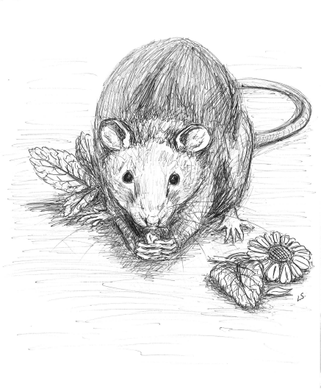
Calming rats with herbs
Lauren Samet, Postgraduate Research Student in Animal Welfare, Moulton College
My PhD is into the efficacy of herbal nutraceuticals in improving captive animal welfare. Nutraceuticals are defined as food, or parts of food, that provide medical or health benefits, including the prevention and treatment of disease. In this instance the study is looking at the benefits of herbs in relation to stress in a captive environment e.g. handling animals. The study will be focusing on herbs used by Dodson and Horrell in their Placid mix for equids and canines. The herbs I will be studying will be Chamomile, Vervain, Lemon Balm, Lime Flowers, and Skullcap in test subject the rat (Rattus norvegicus). The rat subjects will be those used at Moulton College and its associated academies for handling and animal care, because of the variability in subjects there will be many variables to consider in my study design.

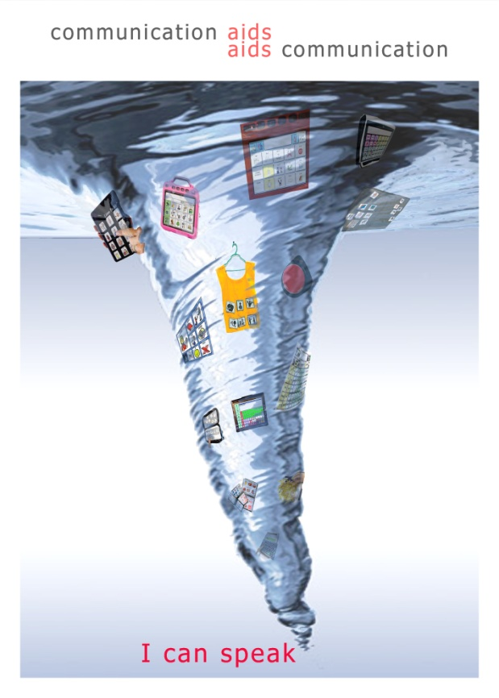
I can speak!
Deb Pugh, Postgraduate Research Student in the School of Health
Communication is natural for everyone! But for some children it can only be achieved through the support of Augmentative and Alternative Communication (AAC) systems. This may include the use of photographs, symbols or computer based communication aids. This research explores the experiences of parents’ and children who use communication aids and considers how they can be supported within the home.

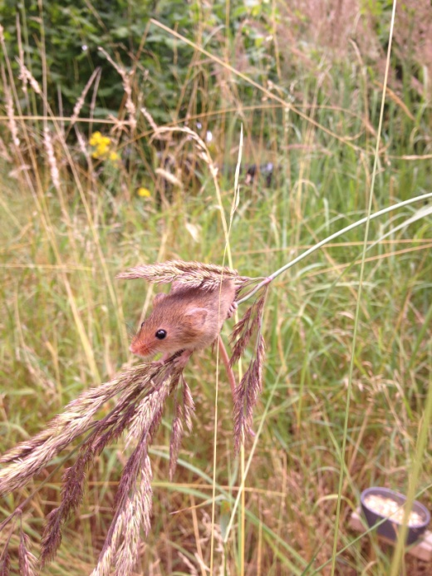
I’m free!
Emily Howard-Williams, Postgraduate Research Student in Animal Welfare, Moulton College.
This lucky harvest mouse (Micromys minutus) was the first of 50 mircochipped individuals to be released on to the Moulton College estate in the summer of 2013. The harvest mouse is an elusive and subsequently understudied species and this research aims to develop current knowledge of their behavioural ecology. Novel monitoring methods developed as part of this project are already unearthing some interesting results.
The young of the released mice are now being trapped, microchipped and now doing their bit for the conservation of the species. Monitoring will continue over the coming year and hopefully the results will allow key ecological questions to be answered.

Experiences of e-safety within primary school education
Hayley Henderson-Martin, Northampton Business School
This research aims to establish what the current e-safety teaching strategies are within primary schools in England in relation to the National Curriculum and current office for standards in education (OFSTED) guidelines. The results of both studies will establish how effective the current teaching strategies are and their impact on young children to provide the necessary evidence to influence key stakeholders and make recommendations and support for an improved strategy and consistent approach to e-safety in primary schools in England. The lives of children are becoming inextricably linked to their online lives and it is becoming increasingly more important for children to be educated from an early age. Research has so far focused more on older children, upwards of age 12 but there is an increasing need to focus research on much younger children in order to help to safeguard their experiences online.

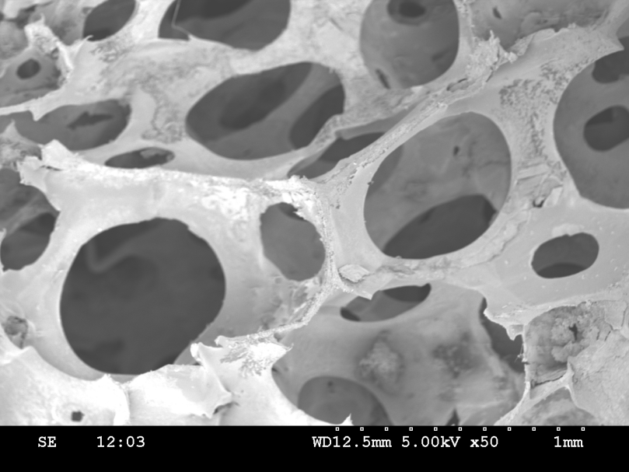
A new home for human skin cells
Ali Poursamar, Postgraduate Research Student in the School of Science and Technology
Some skin wounds do not heal by themselves and need a little bit of help for complete healing. If one can provide the skin cells with a suitable growing substrate in the wound, then cells can grow and prosper much better. This substrate should be similar to natural skin so that cells feel at home and should be porous so that they can move happily around, get together and not get lonely! In this research, gelatin was used to make the substrate which is similar to natural skin’s main ingredient. Gelatin was then turned into foam so that it became as porous as possible. This is an Electron Scanning Microscopy image of gelatin porous substrate with 50X magnification.

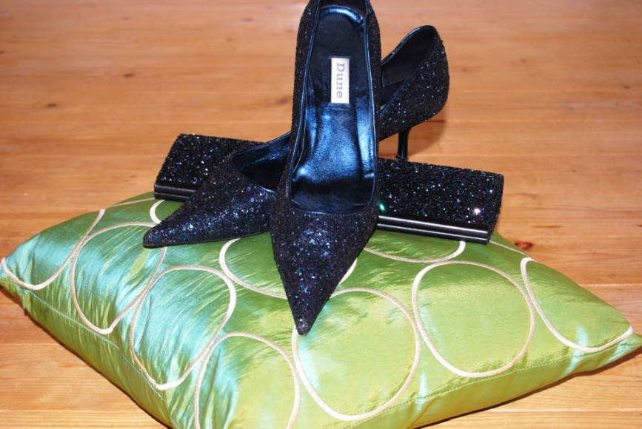
The Cinderella effect: Methodological shoe selection
Jacquie Ridge, Postgraduate Research Student in the School of Health
Whilst sitting attempting a first draft of my methodology chapter I have reflected critically on how and why I am undertaking a research doctorate in the field of Adult Nursing. My thoughts led me to a preferred area of practice, shoe shopping, and reminded me of a picture taken recently – that of a rack of shoes in a recent sale, all shiny bright and just desperate to be tried on, tested out and taken home as a prized possession, much like Cinderella’s glass slipper, or as the image portrayed here. It focussed my thoughts to pose the question, “isn’t shopping for shoes rather like selecting a methodology…what’s its fit, style and motivation; what does it say of, and to what cost to its user?”, which in turn led me to consider “how and why might someone choose to be an adult nurse, and is there a ‘Cinderella effect’ there too?”

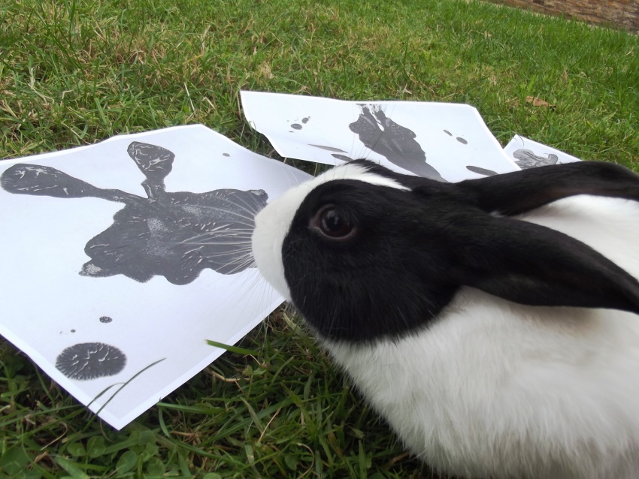
On the couch with a rabbit: Investigating personality in the domestic rabbit
Clare Ellis, Postgraduate Research Student in Animal Welfare, Moulton College
The existence of personality traits in animals is a subject that may be greeted with some scepticism. However, the development of personality assessment tools for use in non-human animals may have wide ranging consequences for the care of captive species, and the roles they play in human society. This research is looking at devising a catalogue of personality traits for the domestic rabbit, and generating a tool to accurately assess personality in pet rabbits.
The picture depicts a domestic Dutch rabbit in a mock-up of an inkblot test. The inkblot test, also known as the Rorschach test, is used to assess characteristics of an individual’s personality and is used in cases where individuals are unwilling or unable to openly discuss their thoughts.
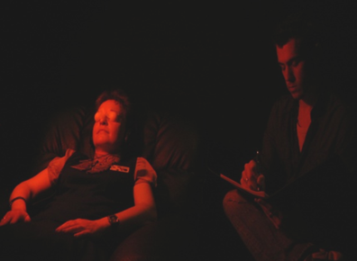
Capturing extrasensory perception in the laboratory
Professor Chris Roe, School of Social Sciences
Parapsychology is concerned with the scientific investigation of so-called paranormal experiences. Research involves exploring how phenomena might be explained in conventional psychological terms, e.g. as due to suggestion effects or selective memory. However, parapsychology also attempts to reproduce these experiences in the controlled conditions of the laboratory that can rule out those normal explanations. Experiments need to closely reflect the real-world occurrences if they are to have any ecological validity and a significant proportion of experiences occur when people are in mild altered states of consciousness (such as when meditating, dreaming or on the cusp of sleep). A common technique for shifting partcipants into ASCs is the ganzfeld, which involves producing an unpatterned visual field (red light that is diffused by eye shields) and auditory stimulation (white noise) to encourage internally generated imagery. Using this technique, researchers in CSAPP have been able to produce significant scoring in a series of experiments, replicating effects reported by labs around the world.
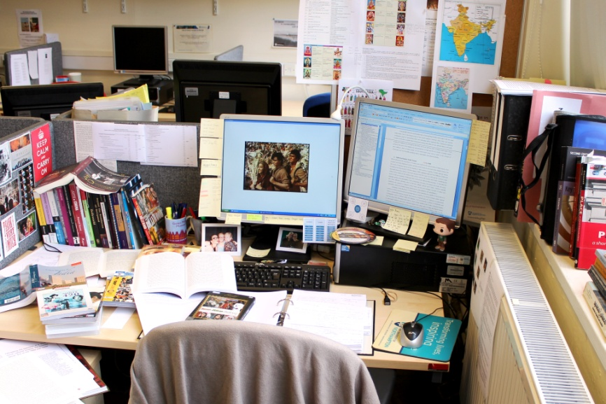
Practice of research
Anna Maria Everding, Postgraduate Research Student in the School of the Arts
This image was taken one not-so-sunny Sunday afternoon in MY119 at Avenue Campus where I am undertaking my research into popular Hindi and British South Asian cinemas and constructions of place, identity and belonging. Since starting my PhD in 2011, I spent most of my time in this room, watching movies, reading articles, jotting ideas and drawing conclusions. Over the course of the time various notes and general pieces of information supporting my research got accumulated in this space alongside books, DVDs, articles and empty coke bottles. Rather than using a still from one of the films I am working on or a picture I took while undertaking field work in India, I decided that this picture of my work space best describes how my research works – text based and analytical.

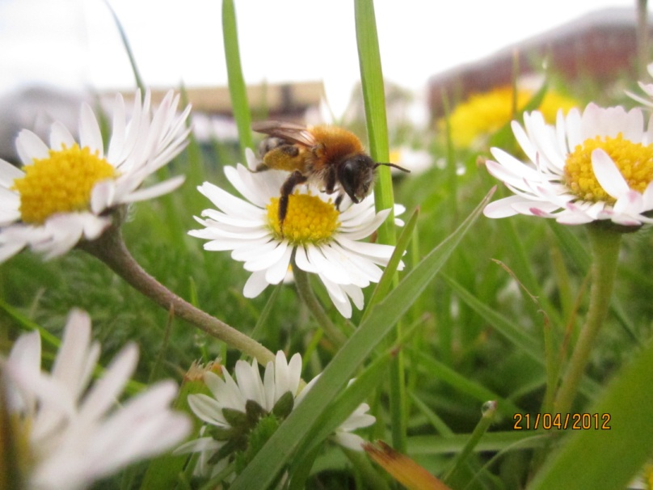
We simply co-exist, think before you conceive them commodity
Muzafar Hussain, Postgraduate Research Student in the School of Science and Technology
Andrena nitida, a solitary bee foraging on Bellis perennis (Daisy) flower present at a wild floral patch in Northampton town. Solitary bees are important pollinators which provide pollination services to a substantial extent for the production of fruit and vegetables, and seed set in wild plants. Unfortunately solitary bees are declining. Urban areas are presumed to have the potential to support solitary bees because of their microclimatic environments. The small mosaics of wild floral patches along with gardens provide substantial resources for living to those wild bees.

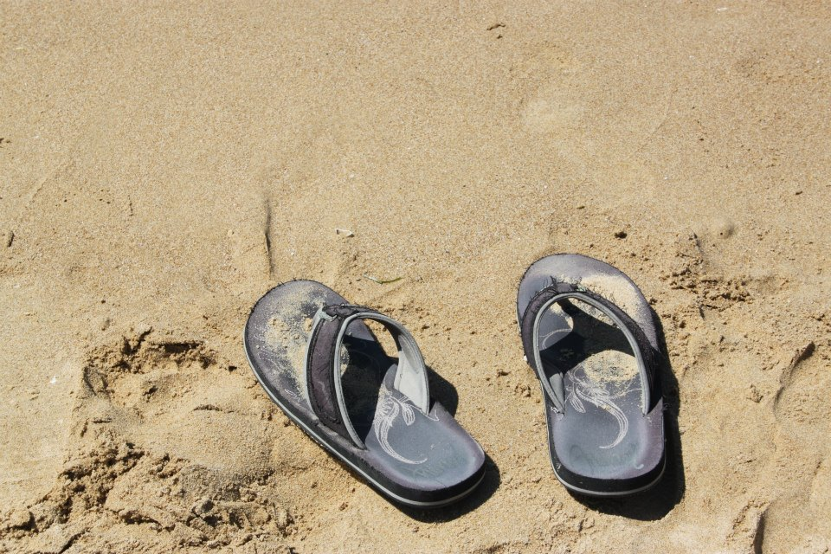
Sink or swim?
Angie Bartoli, Postgraduate Research Student in the School of Health
My research is about capturing the feelings held by social workers who have recently become supervisors or managers. Many who describe this new job role use analogies associated with water. For example: being abandoned ‘at the deep end’, or that it is a matter of ‘sink or swim’. This pair of discarded shoes, taken during the summer whilst thinking about my research, represents the loneliness often associated with new beginnings. Does the owner of the shoes plunge into the deep end and eventually return? Or are they too overwhelmed, gasping for breath and fail to resurface?

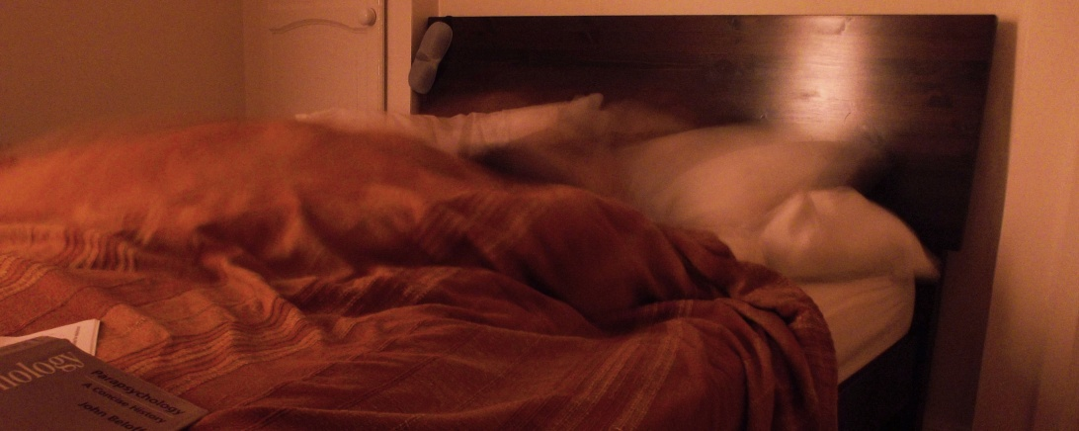
Extrasensory experiences: Beyond the waking state
Elisa Fernandez, Postgraduate Research Student in the School of Social Sciences
As parapsychology continues to explore extrasensory experiences such as telepathy, clairvoyance and precognition (generally known as psi), past research has provided evidence that a large number of these experiences occur while an individual is in an altered state of consciousness. With the majority of these states being regarded as passive or indirect, (with the experience happening to the individual, not the individual actively or directly taking part) this restricts researchers to investigating only certain conscious states.
The focus of my research looks at using a relatively new auditory meditation technique to directly induce altered states of consciousness that have been associated with enhancing psi performance, and to determine whether the measured states are associated with the occurrence of any extrasensory experiences. Using a direct technique will explore what influences particular states have on psi performance, and help narrow down psi elusive nature.

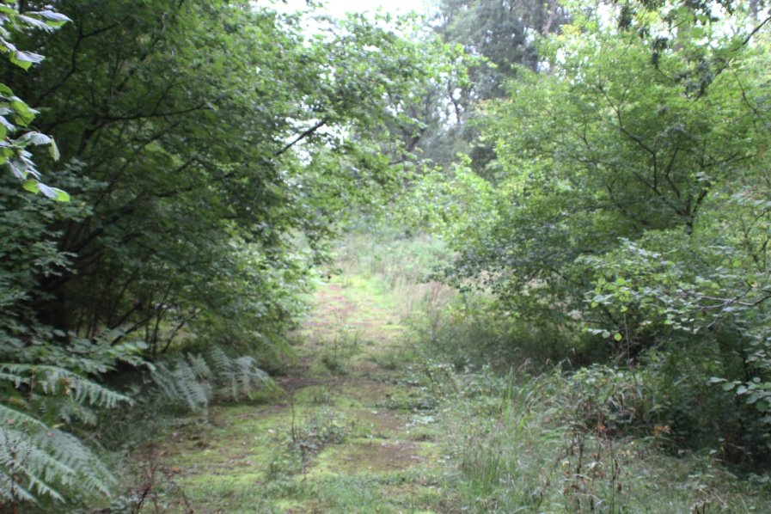
‘Ear’ or there
Carmel Capewell, Postgraduate Research Student in the School of Education
Visual images have been central to gathering data of how mothers of children with chronic Glue Ear, which causes intermittent hearing loss, describe their experiences and emotions. This image summarises their descriptions. The path isn’t clear in any sense: although there is a track, it’s not easy to see, there is an element of it being the same, like 6 monthly hospital visits for check-ups. The path is not well-worn as there are no formal opportunities to meet others in the same situation. There is a feeling of isolation. Negotiating obstacles is important – the child’s frustration at not hearing; prepared to bend to the expertise of health and educational professionals who don’t recognise the mother’s expertise. Constantly looking for the bright spots is a way of keeping optimistic. The corner represents the hope that turning it will mean the glue ear will resolve as is described as ‘temporary’.

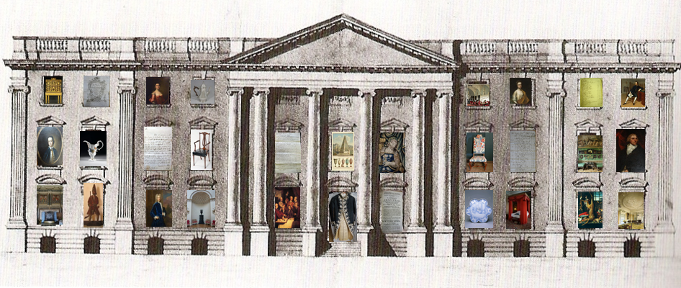
Consuming the country house
Professor Jon Stobart, School of Social Sciences
The country house as palimpsest is a familiar idea - each generation of owners laid down their own strata of goods, covering and in part eroding, but also incorporating the existing material culture of the inherited house. But in many ways, this analogy of layering is too neat. The country house was, perhaps, more of a collage: different rooms, goods and people forming distinct, but related parts of the picture. This composite and inevitably rather messy picture is revealed through surviving material objects, and also in bills and wills, plans and inventories, diaries and letters. These tell us about the ebb and flow of goods, the networks of supply, and the dreams, desires and everyday concerns of those who owned and lived in country houses.

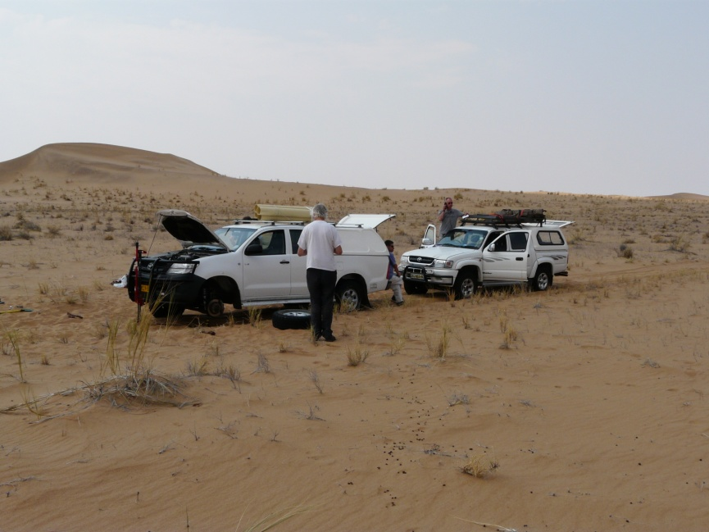
The day the wheels came off our project
Professor Ian Livingstone, School of Science and Technology
It is Saturday 7 September 2013. A wheel has sheared off our vehicle in the southern Namib Desert in Namibia, southern Africa. We are 60 km from the nearest road, 100 km from a town. One of our group of five UK geomorphologists (scientists who study the development of landscapes) is phoning a mechanic on a satellite phone. Wonderfully, the mechanic arrived on Sunday; assessed the problem; went home; ordered the parts required on Monday; returned to fix the vehicle on Tuesday. In the meantime we set up a weather station which will collect information over the coming years about winds in this desert: really important if we are to understand the present-day development of the dunes. We also used ground-penetrating radar of the internal structure of the dunes which will help us understand their past development and we took samples of sand which will be dated to tell us the age of the sand in the dunes.
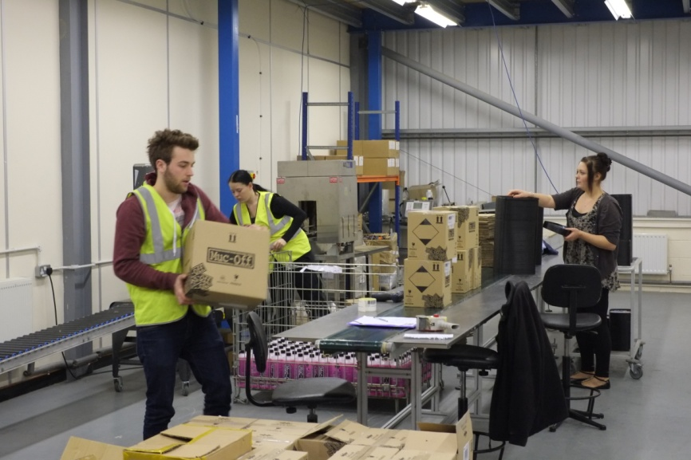
Knowledge Transfer Project with Total Logistic Services Ltd
Dr Liying Meng, Senior Lecturer, Northampton Business School
Total Logistics has undergone several progressive transformations since its inception in 1989. These changes have related mainly to branding, premises and technology, but the thrust of business development has invariably been entrepreneurial by nature. This approach has ensured the survival of the company, but has precipitated a culture whereby the pursuance of new business opportunities is not always balanced with the development of business processes. For example, the image shows employees working on a large bottling and storage contract. This project made a loss of £70,000 because labour and other variable costs had been based on client information rather than accurate project cost analysis. Moreover, the losses were not realised until they had become considerable.
Dr. Liying Meng, of Marketing and Entrepreneurship Group, obtained finding from the Technology Strategy Board for a Knowledge Transfer project to help the company with its adoption of advanced business processes including financial decision processes.
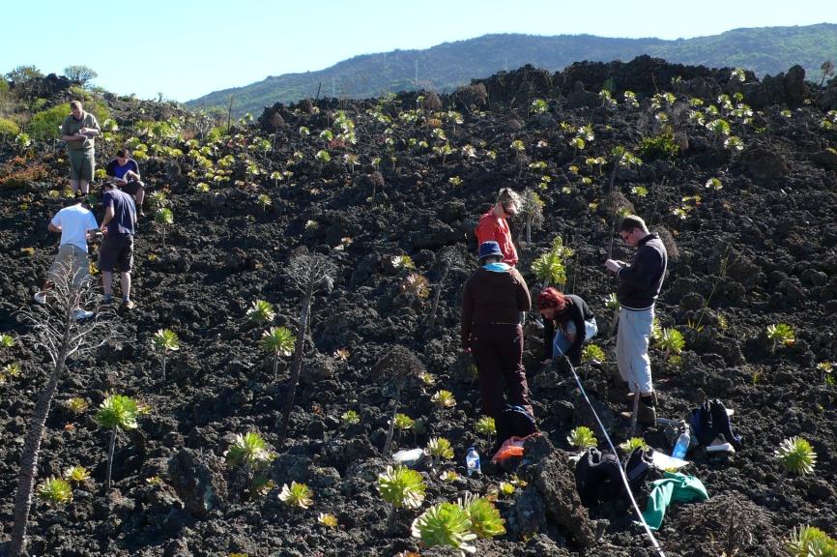
Students on the Aeonium field
Professor Jeff Ollerton, School of Science and Technology
For over ten years undergraduate students have been involved in research data collection as part of the UoN Tenerife Field Course. The students in this image are measuring the sizes of individuals in a population of an endemic plant species. The plants grow for up to 20 years then suddenly flower, set thousands of seeds, and die. What triggers this flowering? The data collected by students between 2006 and 2013 suggests that it is drought: dry winters trigger more plants to flower. This year we set up some experiments to test this hypothesis by laying clear plastic sheeting around a sample of plants, and artificially watering others. The field course returns to Tenerife in April 2014 when we will assess the results of the experiment. Extreme dry events are increasing in frequency on Tenerife as a result of climate change. How might this affect the future ecology of such plants?

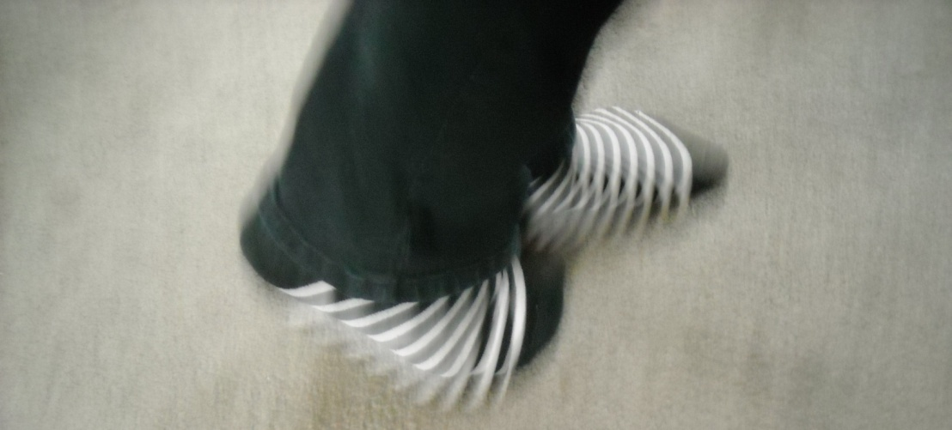
Walking the talk
Jacqueline Stone (Photograph by Laura Growney-Stone), Postgraduate Research Student in the School of Social Sciences
This image pictures my feet during walking meditation. In this mindfulness practice, the focus of attention can be brought to the feet and to any and all sensations therein during the process of standing still, walking and then standing still again. Through this practice, the attention may shift from mind and more into body, resulting in less mental ‘chatter’ and a feeling of being grounded and calm. As well as being a researcher of mindfulness in schools, I am also a practitioner and teacher of mindfulness. This means that in order to be authentic, I walk the talk. In this way, I am better able to understand the experience of mindfulness and to relate to the experiences of others when they practise. My footsteps here also represent the PhD path that I am currently treading and the associated changes in pace, movement and feelings that I experience along the way.

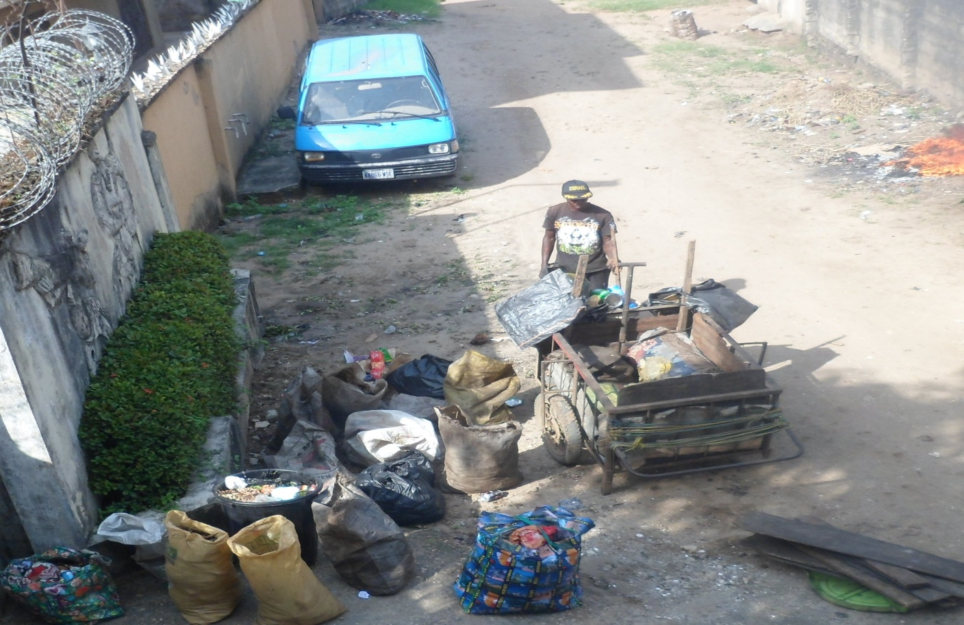
‘Durrti dey’ (I need your solid wastes)
Chinyere K. Abaneme, Postgraduate Research Student in the School of Science and Technology
The caption ‘Durrti Dey’ is a slang shouted by scavengers along streets to get the attention of residents interested in disposing their generated waste at a negotiated price. The impacts of waste scavenging, and how it contributes to the socio-economic growth and environmental sustainability in Aba, a City in the Southeast of Nigeria is the key aim of my research.
This picture clearly shows the preparation to segregate solid wastes collected from households. The different reusable jute bags contains separate types of recyclables to be sold to recyclers, on the other end, the fire burns papers as they are valueless to the scavenger, while the wood is set aside to be sold to commercial food sellers for firewood. Afterwards, the scavenger pushes the truck made from scrap metals to a dumpsite where the remaining organic and residual solid wastes are finally disposed of.
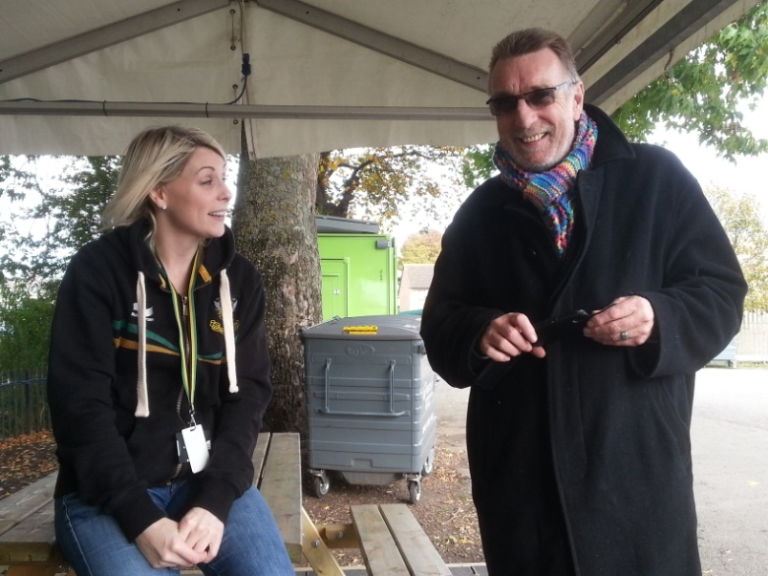
Fandom & followers
Alan J Seymour, Northampton Business School
Capturing fan engagement, personified in this photograph, and its importance with sporting supporters, is fully reflected in this recent visit to Northampton Saints Rugby Club. Following on from initial ‘economic impact’ research with the Club and its supporters, a new piece of research is being conducted on how social media impacts on fans and the ‘tribal’ support of their devoted team. The research that is to be undertaken commences with student involvement on match days at Premiership games, through the University’s branded new stand in the hospitality village section prior to the game. This activity also supports the recent sponsorship association between the Club and the University.
The students will be involved in gathering data from supporters on their social media activity in supporting their team. This will also add to the student experience for sports, events & tourism students at a live event.

E-government: From bureaucratic paradigm to citizen participation
Yousef Forti, Postgraduate Research Student in the School of Science and Technology
E-government promises high quality of services to citizens, businesses and other stakeholders. In developing countries like Libya, where the centralized and bureaucratic government heavily impact on citizens’ lives,
E-government could increase citizen participation in the life of their society, government and community, which means less bureaucratic government. E-government also promises to be successful by offering more efficient, transparent and accessible public services to citizens and stakeholders as e-business and e-commerce in private sector. In the case of Libya e-government reduces the distances between government departments and citizens by providing government services online, so citizens can obtain their service while they are at home. All of these services are computer-based technologies which leads government to reinvent itself, providing services in an exciting way.

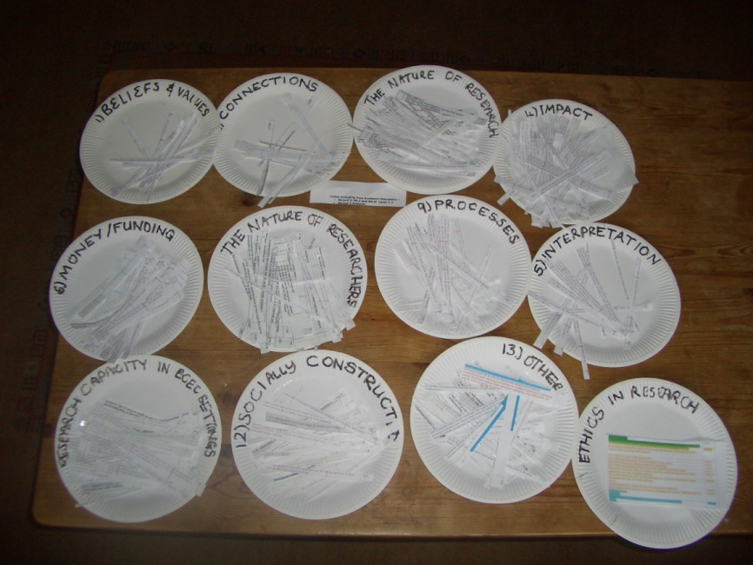
Research analysis on a plate
Dr Jane Murray, School of Education
Research behaviours present naturally in children younger than eight years but are often overlooked by professional researchers, so young children are rarely recognised as agents in enquiry concerning matters affecting them. The Young Children As Researchers (YCAR) project is a grounded theory study conceptualising young children aged 4-8 years as researchers. In YCAR’s initial phase, 36 professional researchers were invited to define research, generating many data to be coded, line-by-line. In a low-tech process, I laid out blank paper plates and cut up individual ‘lines’ of data. I placed each on a plate, constantly identifying meanings amongst the data lines which developed into themes. Each plate became a theme – or code - which I wrote on the plates once data lines were distributed. These Phase One data later evolved into a Research Behaviour Framework which was applied to children’s activities at home and at school in subsequent YCAR project phases.
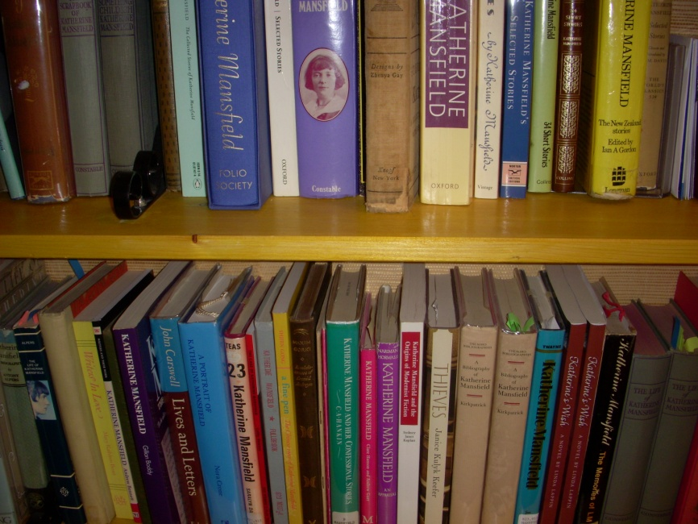
My Katherine Mansfield life
Dr Gerry Kimber, School of the Arts
When I was doing my PhD at Queen Mary, University of London and then Exeter (my supervisor took up a Chair and I moved with her), I lived in Gloucestershire. Trips to London and Exeter were expensive and it was cheaper to buy the books I needed for my research than pay for train fares to get to libraries. Buying them from the USA was much cheaper, even allowing for postage, and I spent hours scouring websites looking for the cheapest copies possible. Now I have an incredible Mansfield research library at my fingertips, and in the ensuing years have become a world authority, with my own publications to add to my still growing collection!

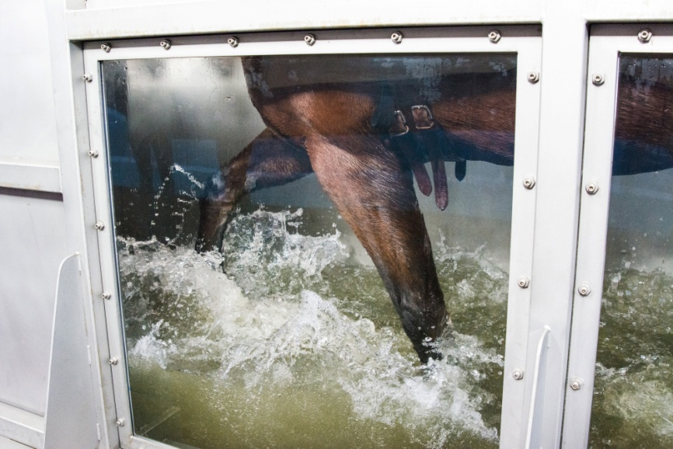
Sink or Swim?
Jessica York, Postgraduate Research Student in Equine Science, Moulton College
Equine Hydrotherapy is increasingly applied within the equine industry with the development of state-of-the-art Equine Hydrotherapy Centres such as the facility at Moulton College. The Therapy Centre at Moulton College houses a straight line swimming pool with water jets, a spa, a solarium and an aqua-treadmill. Comparatively, little research has been conducted on the equine aqua-treadmill and movement of the horse on an aqua-treadmill needs to be studied and quantified in order to accurately determine the effects and potential benefits of aqua-treadmill exercise. My current research has focussed on tracking three-dimensional coordinates of anatomical landmarks on the horse’s axial skeleton when undergoing an exercise protocol through a series of increasing water depths to quantify the horse’s movement and identify patterns of symmetry. It is anticipated that an optimal water depth and exercise protocol may be determined to best promote rehabilitation and therapy methods in the individual equine athlete.

All images printed by the university of Northampton photography department

Special thanks to Steve Godfrey and Kartini Leet from the photography department for their help and advice

The Graduate School
University of Northampton
www.northampton.ac.uk/graduateschool
Research Support Hub: http://researchsupporthub.northampton.ac.uk/
facebook UnGradSchool twitter @UNGradSchool in ungraduateschool

