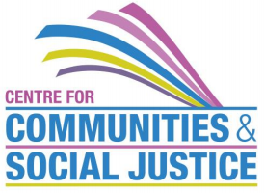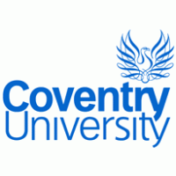
Negotiating Mixed Ethnicity/Heritage Relationships Seminar
Wednesday 24th June 2015, 9:45 am to 3.15 pm
Room 152, Jaguar Building, Coventry University
Aims/Objectives
Historically, debates about ‘mixed race’ families have centred on Black/White relations concerning issues of identity, belonging and racism affecting the partner and their children. Though these issues have not gone away, we are also seeing an emergence of new configurations and challenges of family diversity involving inter-faith, inter-caste and inter-ethnic relationships.
This workshop seeks to provide a forum to debate and share experiences. Anyone interested from an academic, personal or professional perspective in these emerging forms of family and social diversity are welcome to participate.
Keynote Speakers
Dr Omar Khan – Director Runnymede; Member of the Department for Work and Pensions' Ethnic Minority Advisory Group, UK representative on the European Commission’s Socio-economic network of experts.
Audrey Allas – PhD Student, University of Durham; research interests are in interfaith relations, particularly between Abrahamic traditions, intermarriages involving British Pakistani Muslim communities.
Programme:
9.45 – 10:00 Registration and coffee
10.00 – 10:15 Welcome and Opening Remarks – Dr Gurnam Singh, Principal Lecturer, Coventry University
10.15 – 11:15 Dr Omar Khan – Empirical research on Mixed Race/Mixed Ethnicity
11.15 – 11:30 – Coffee Break
11.30 – 12.00 Small Group discussions
12.00 – 12.30 Feedback
12.30 – 1.15 Lunch
1.15 – 2.00 Ms Audrey Allas – Mixed Race relationships
2.00 – 2.30 Small Group discussions
2.30 – 3.00 Feedback
3.00 – 3.15 Closing Reflections: Professor Hazel Barrett, Director Centre for Communities and Social Justice
There is no charge for the seminar but booking is essential. To book a place please visit https://www.eventbrite.co.uk/e/negotiating-mixed-ethnicityheritage-relationships-tickets-16615757177

