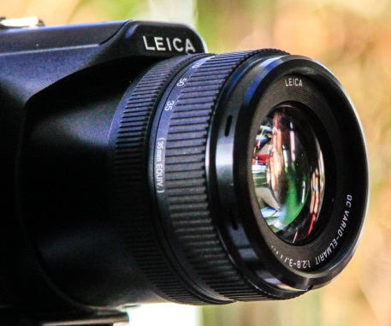
 Images of Research 2015-16
Winning images Chosen by voters at the exhibition and online

1st: Muscle by numbers.
Dr Karen Anthony, Lecturer in Molecular Bioscience, School of Health.

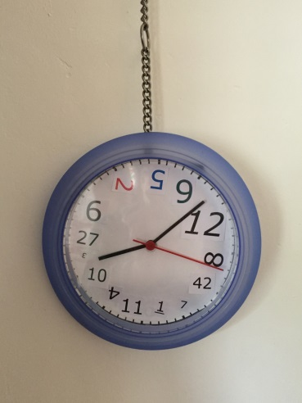
2nd: The Clocks have changed.
Dr Carmel Capewell, Associate Researcher/Lecturer, School of Education

And

2nd: Romanticizing the Devil: The Gothic in twenty-first century young adult fiction.
Meriem Lamara, Postgraduate Research Student, School of the Arts.


4th: Sink or swim.
Emma Whewell, Postgraduate Research Student, School of Education.

www.northampton.ac.uk/graduateschool
Research Support Hub: http://researchsupporthub.northampton.ac.uk/
facebook UnGradSchool twitter @UNGradSchool in ungraduateschool

