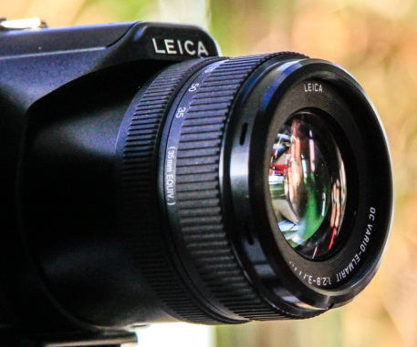
 Images of Research 2015-16
Winning images Chosen by guest judge Roy Wallace
We asked Roy Wallace, Senior Lecturer in Media Production in the School of the Arts, to choose his top three Images of Research. These are his winners – and why he chose them.

1st: A snapshot of whose worlds and meanings? Kim Dodd.
This image and the contextualising statement evoked a range of emotions for me, which is why I chose it for first place. I never really thought of Social Workers as caring champions of social justice for vulnerable people in our communities. This image connected the essence of the research, the impact on the personal and family support required to undertake postgraduate research, while offering a conceptual framework where the research is a ‘journey’ with the focal point often turning on oneself along the way. The partially hidden aspect to the image offers ‘polysemic’ reading of the text which appeals to me and left me unsettled trying to make sense of the ‘intention’ of the photographer.
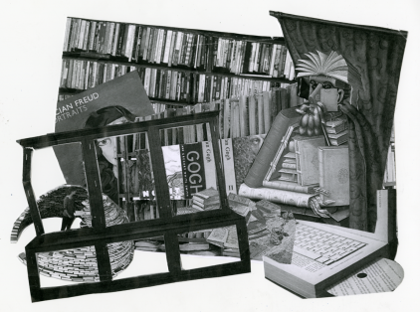
2nd: Back to Books. Dr Helen Scott.
This image took me back to the work of artist Gee Vaucher, who worked around various existentialist themes evoking a pleasurable reminiscence while revealing the nature of the producer’s research project and the importance of books as interview data feedback. The way the image has been constructed offers a window into the research project and helps position the central theme. The image made me work at its interpretation which I enjoyed and the contextualising statement anchored my unsettled reading of the text.

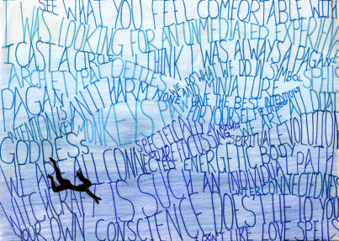
3rd: Immersed. Charmaine Sonnex.
I was challenged to decide between ’The Clocks have Changed’ (Dr Carmel Capewell) and Immersed for 3rd place.
In the end I decided that while ’The Clocks have Changed’ had many positive aspects Immersed ‘haunted’ my interpretation as this image presented a deep reading questioning my own position regarding the nature of the research. Using statements from interviewee’s the image producer worked to weave research methodology with spiritual understanding around the central theme in the work. Researching the effectiveness of Pagan ‘spells’ in an academic context is an interesting subject to explore and the image presents us with a central figure immersed in a sea of individual understanding of the research ambition while disturbing my rational critical thinking around this proposed subject material. I am still thinking about this research project!

Roy Wallace (BA Hons, PGcert T&L, PGdip Fine Art, FHEA),
Senior Lecturer Media Production, School of Arts, University of Northampton
roy.wallace@northampton.ac.uk www.uontv.uk Member: British Association of Film Television and Screen Studies

