SCHOOL OF EDUCATION SEMINAR

‘I look away until they have finished reading it!’
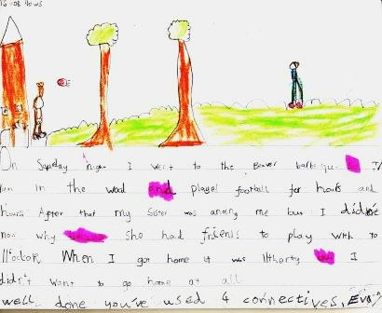

Led by
Dr Michael Catchpool
(School of Education)

Children’s engagement with writing in Primary school is often regarded as a concern, particularly in upper Key Stage 2. In this seminar, Michael presents an examination of children as writers through a focus on children’s engagement with and response to peer feedback strategies. Michael’s research centres on his findings related to the introduction of an intervention strategy designed to support children in the feedback process. Crucially, it considers children’s own views and perceptions of the whole process of providing feedback to peers – both the positives and the challenges - and casts some light on to what really happens when teachers say to children, ‘Turn to the person next to you and discuss your ideas.’
Date: Wednesday 13.7.16
Time: 1-2pm
Room: S014
Park Campus, University of Northampton, NN2 7AL

Free of Charge
All welcome
We look forward to seeing you there!

- Facilitated by the Centre for Education and Research –
E-mail jane.murray@northampton.ac.uk for more information

