
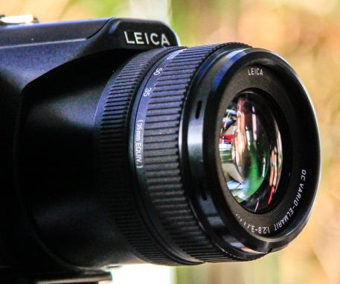
Images of Research 2016-17
Guidelines for voting

Please vote for your top three favourites.
Images of Research is essentially about making research accessible. The Images of Research competition offers researchers a chance to illustrate or represent their research using a unique image, along with an abstract of up to 150 words describing how the image reflects their research. As a guide, a winning image would be one that:
- Is visually appealing AND
- Has an accompanying abstract which is well written, clearly connects with the image and ensures viewers, who know nothing about the research topic, will understand and find interest in the research presented.
So please vote for your favourite three in no particular order, taking into account BOTH the image and the abstract.

The IoR catalogue, containing the images and abstracts, is available online on the Research Support Hub from February 1st, where you can also vote – see http://tinyurl.com/IoR2017. You can vote at the exhibition which will travel between campuses.
- 1st-17th February 2017 in Avenue Gallery corridor, Maidwell Ground Floor, Avenue Campus.
- Mid-February to 13th March 2017 in Rockingham Library Ground Floor,
Park Campus.
- Mid-March to 13th April 2017 in Avenue Library entrance.
Please direct any queries or feedback to simone.apel@northampton.ac.uk

