FACULTY OF EDUCATION AND HUMANITIES SEMINAR PROGRAMME

Rapid Railways, Caves of Cravings, Relaxing Breezes and Vulnerable Valleys

Exploring the relationship between early childhood practitioners’ beliefs and their use of mobile technology to support young children’s literacy engagement

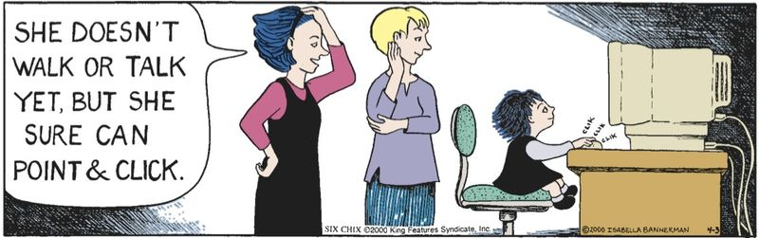

led by
Michelle Bugby

In this seminar, Michelle shares her findings drawn from a qualitative study which investigated the influences and implications of mobile technology for early educators who ‘create and shape the learning environments in which our children grow up’ (Kucirkova, 2013: 116). In the seminar, Michelle will reveal the innovative visual method she adopted to explore how iPads can offer exciting opportunities for children’s emergent literacy learning. She will also discuss challenges educators encountered when using the iPads as a pedagogic tool.

Wednesday 15th March, 2017
Time: 1.15-2pm
Room: S010
Park Campus, University of Northampton, NN2 7AL
All welcome

Bring your lunch: we look forward to seeing you there!

- Facilitated by the Centre for Education and Research –

E-mail jane.murray@northampton.ac.uk for more information

