FACULTY OF EDUCATION AND HUMANITIES SEMINAR PROGRAMME
The Social Construction of Children's Centres

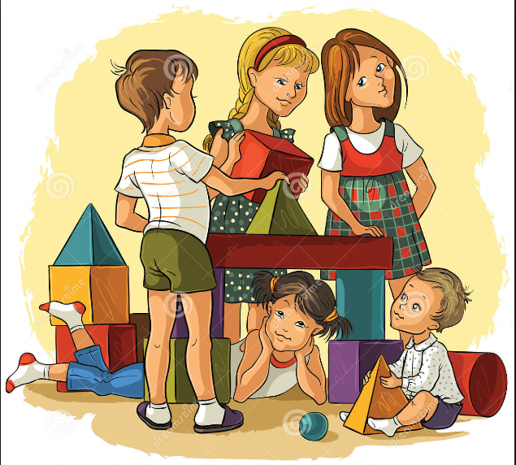

led by
Peter Goy

New Labour opened 3500 Children’s Centres with a remit to improve outcomes for young children and their families and reduce inequalities. Now they are closing: in October 2016, there were 3,259 with reports of more closures imminent. In this seminar, Peter Goy will share findings from a qualitative study that adopted discourse analysis to investigate perceptions of Children’s Centre services, the ways they have changed and the effects of those changes on outcomes for children, families and Children’s Centre workers.
Wednesday 22nd February, 2017
Time: 1.15-2pm
Room: S029
Park Campus, University of Northampton, NN2 7AL
All welcome

Bring your lunch: we look forward to seeing you there!
- Facilitated by the Centre for Education and Research -
E-mail jane.murray@northampton.ac.uk for more information

