FACULTY OF EDUCATION AND HUMANITIES SEMINAR
An Exploration into the Student Experience of
Blended Learning

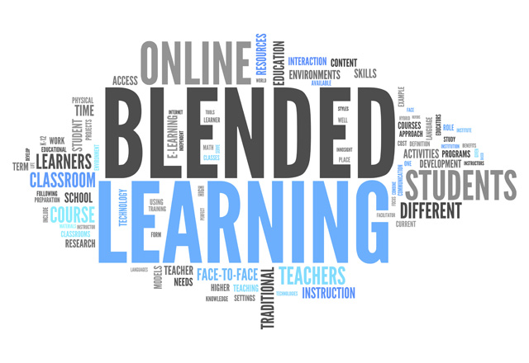

led by
David Cousens

In this seminar, David explores the experiences of Blended Learning from the perspective of Year 1 students. Consideration will also be given to the links between previous research into the area and the lived experience of the students. From this exploration initial conclusions will be discussed about this approach to learning.

Thursday 2nd March
12.00 - 1.00pm
S007
Park Campus, University of Northampton, NN2 7AL

All welcome

We look forward to seeing you there!

- Facilitated by the Centre for Education and Research –

E-mail jane.murray@northampton.ac.uk for more information

