
Images of Research 2016-17
Winners chosen by guest judge Ralph Derbyshire,
Principal Lecturer and Subject Leader in Fine Art, UoN.
We asked Ralph to choose his top three, taking into account the image and the research abstract. His choice is below, along with a summary of why he chose them.
1st - Telling Tales: a Labour of Love, by Claire Clews, Postgraduate Research Student, Midwifery, Faculty of Health and Society
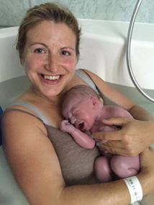
It is quite difficult to conceive of an image which is more fundamental to everything that gives us hope, meaning and joy, while at the same time begging so many scientific as well as abstract thoughts. That this picture was gifted to Claire adds an intriguing layer of disconnection, which belies the gaze of the mother to the photographer and allows the image a persuasive enigmatic association within the context of her text.
This is a powerful photograph, and excellent illustrative choice.

2nd - The Unconventionality of Venues for Writing, by Jacquie Ridge, Postgraduate Research Student, Adult Nursing, Faculty of Health and Society.
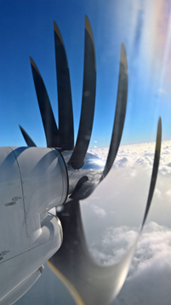
This photograph reminds us of the shared nature of research and of those communities which reach beyond the furtherance of study and knowledge and which create important and lasting friendships. The title also reminds us that unconventionality is at the very heart of impactful research. Jacquie’s text is lyrical and highly evocative capturing an authentic moment in time, in contrast to her camera which captures an inauthentic multiple of propellers.

3rd - Animals that Tweet, by Kardi Somerfield, Senior Lecturer in Marketing,
Faculty of Business and Law
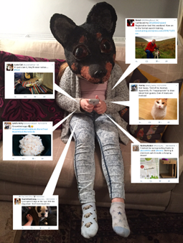
This is clearly a highly visually appealing image and one which has had time and a great deal of three dimensional skill invested in it. However Kardi’s submission is not only admirably unreserved and humorous, but it signifies that blind, and at times not quite so blind alleys should through the course of good research be meandered down. It certainly is curious!

