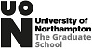
Images of Research 2016-17
Winners Chosen by voters at the exhibition and online

1st
Zainab Al-Rubaye, Postgraduate Research Student, Computing and Immersive Technology, Faculty of Arts, Science and Technology, with Moulton College.
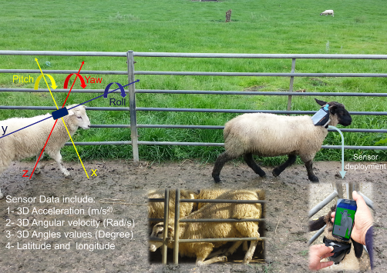
Lameness is a clinical symptom related to movement disorder in the locomotion systems of the animal. It is considered one of the primary welfare concerns in the sheep industry in the UK due to the annual loss, which is estimated to be £10 for each ewe according to a 2016 Agriculture and Horticulture Development Board report. This research aims to develop an automatic model for early detection of lameness in sheep by analysing the data that will be retrieved from a sensor mounted on a collar on the sheep’s neck. This extensive spatiotemporal data will be classified to infer the associated behaviour of the lame sheep. The prior detection of the lame sheep will be expected to decrease the prevalence of lameness and enable the shepherd to react quickly with better treatment.
2nd
Maitreyee Buragohain, Postgraduate Research Student, Special Educational Needs and Inclusion, Faculty of Education and Humanities.
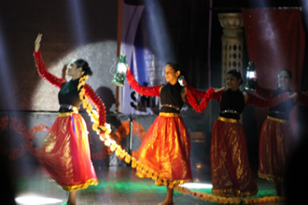
"Have feet will dance. Have spirit will triumph" - Shiamak Davar. Dance guru Shiamak Davar's mantra resonates in his dancers. It is with this inspiration that I teach dance to children and young adults with complex needs. Dance has seen me through some pretty dark days. It has helped me to see the light within myself and to discover that happiness lies in enjoying each step along the way, in this journey called life. This is the motivation for choosing a research topic like dance for learners with complex needs. I am positive that my research study will bring joy and help me celebrate the abilities of children and young adults with complex needs.
3rd
Building Castles in the Air, by Dr Saneeya Qureshi, Institute for Social Innovation and Impact (ISII), Research, Impact and Enterprise.
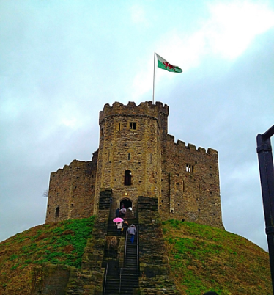
As a doctoral student, I had dreams of a job that melded my passions for research and educational support. Fortunately, I was appointed to the role of researcher in social innovation and impact; and shortly thereafter, invited to the prestigious position of Link Convenor of the Emerging Researchers Group (ERG) for the European Educational Research Association (EERA). I shared my vision for the ERG with a panel of EERA Council Members from across the region, and I was successful! Today, as an early career researcher, I travel extensively across Europe, representing the interests of the ERG, fostering cooperation with other EERA networks. I sit on the EERA Council and am principal organiser of the Emerging Researchers Conference which is held in a different European city annually, attracting thousands of participants on a global scale. Those castles that I built in the air are still there, but I am gradually putting foundations under them.

